MEHRAN UNIVERSITY

OF ENGINEERING & TECHNOLOGY

JAMSHORO, PAKISTAN

To be able to physically cable a peer-to-peer and switched network

Subject: COMPUTER NETWORKS (PR)

(Lab 3 - Tasks Solution)

|  |  |
| --- | --- |
| **Roll No:** | **22SW028** |
| **Section:** | **I** |

**LAB TASKS:**

**1.** **Which cable did you use to connect workstations in Task 3?**

**Ans:** A crossover cable was used to directly connect the two workstations in a peer-to-peer setup.

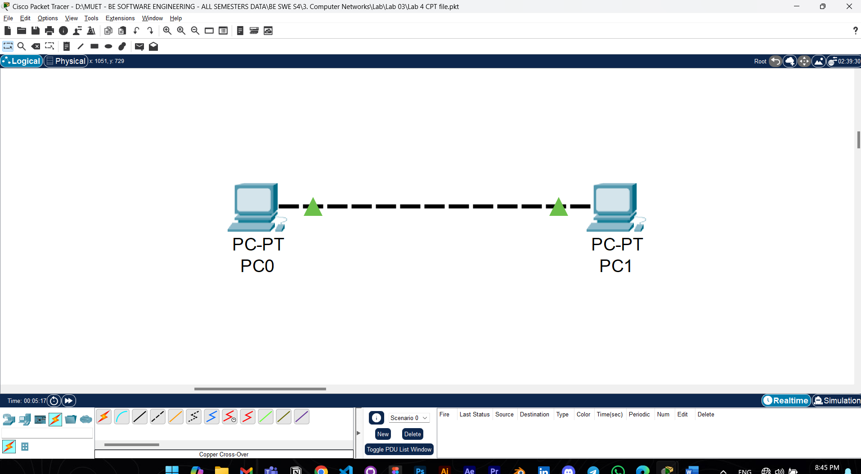

**2. What was the output of ping command in Step 3 of Task 3? What happens if you unplug the network cable and ping the other workstation?**

**Ans:** The output of the ping command was:

FROM PC1 to PC2:

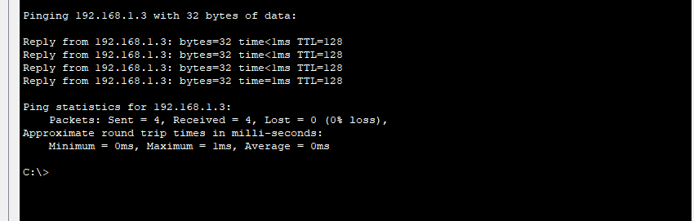

FROM PC2 TO PC1:

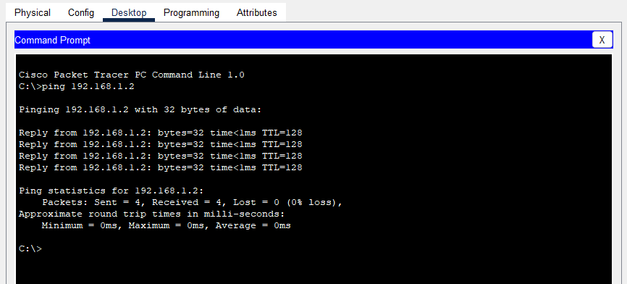

If you unplug the network cable and then try to ping the other workstation, you will get an error message such as "Request timed out" or "Destination host unreachable," indicating a failure in connectivity.

**3.** **What was the output of ping command in Task 4? What happens if you ping an address that is not connected to the network?**

**Ans:** I used Straight Through Cables for connecting PCs to Switch.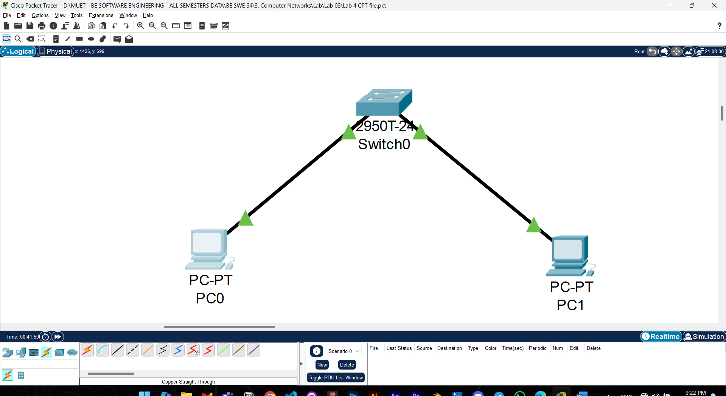

Pinging from PC1 to PC2

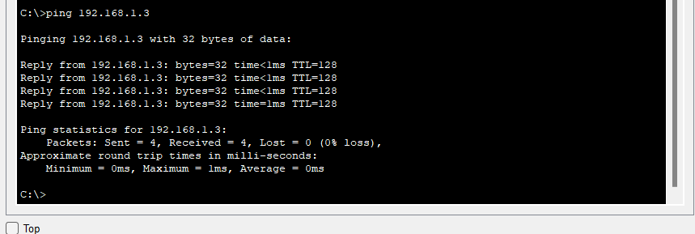

If we try to ping an IP address that’s not connected to the switch, then it will give request timed out error

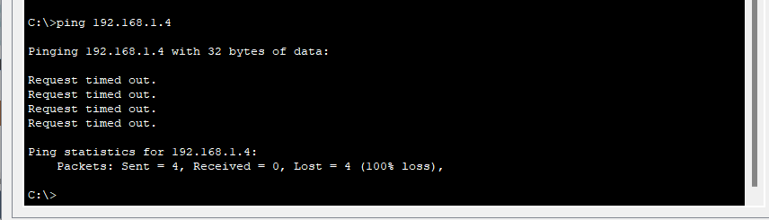

**4. What could prevent a ping from being sent between the workstations when they are directly connected?**

**Ans:** Several issues could prevent the ping from being sent successfully in a direct connection (peer-to-peer setup):

**Incorrect IP addressing**: The IP addresses must be in the same subnet for the two workstations to communicate.

**Wrong cable type**: Using a straight-through cable instead of a crossover cable for direct connection between workstations can prevent communication.

**5. What could prevent the ping from being sent to the workstations when they are connected through the switch?**

**Ans:** Possible issues that could prevent successful pinging between workstations connected through a switch include:

**Incorrect IP addressing**: Each workstation must have a unique IP address in the same subnet.

**Wrong cable type**: A straight-through cable should be used when connecting each workstation to the switch. Using the wrong cable may prevent communication.

**Defective switch or ports**: If the switch itself is faulty or a specific port is malfunctioning, it may disrupt the connection.